1. AIM TO: Design DFA using simulator to accept the string having ‘abc’ as substring over the set {a,b,c}

INPUT:

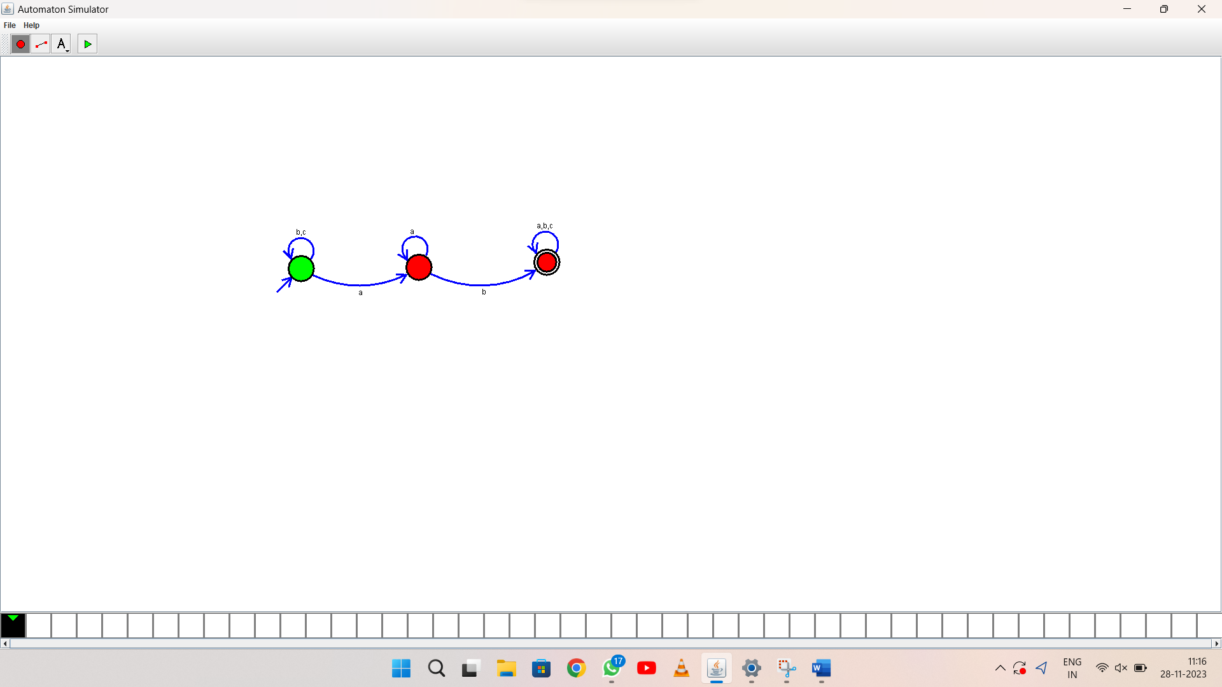

OUTPUT:

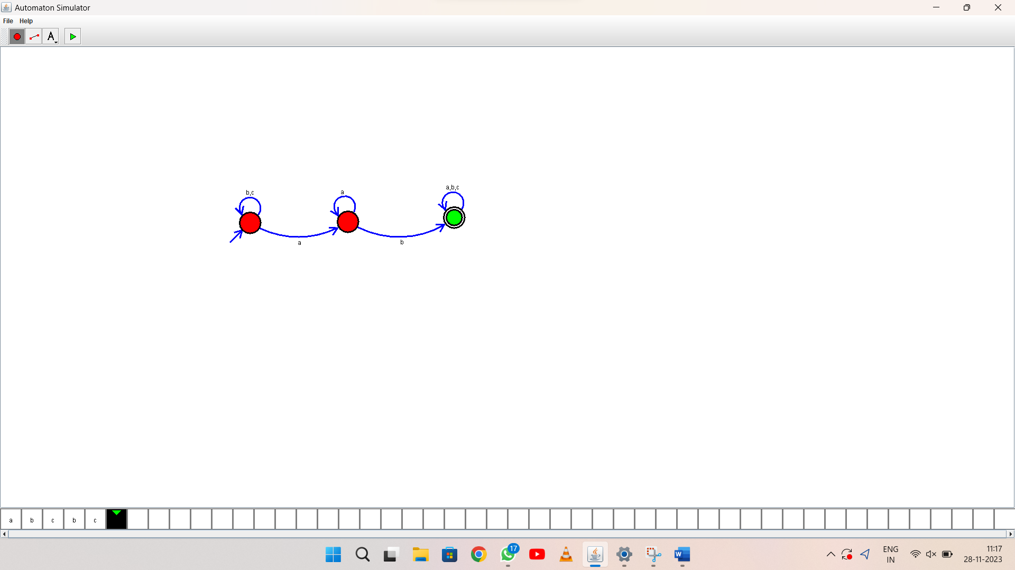

1. RESULT: thus Design DFA using simulator to accept the string the end with ab over set {a,b)

W= aaabab